10.42: Let
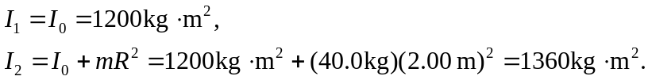

Then, from Eq. (10.33),

